Draw a circle with the size of the inner diameter of the impeller. Here we approximate 3 cm

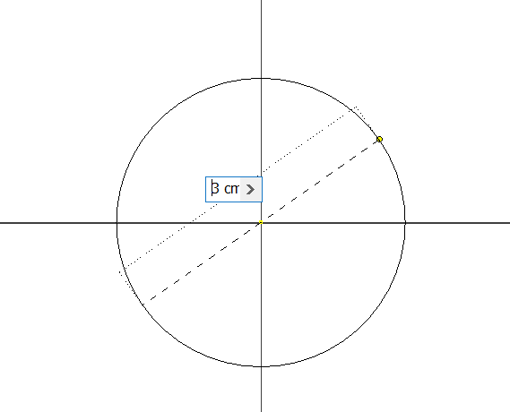

Draw a circle whose center falls on the outer edge of the inner diameter circle. I used 1 cm because it was the first number I found

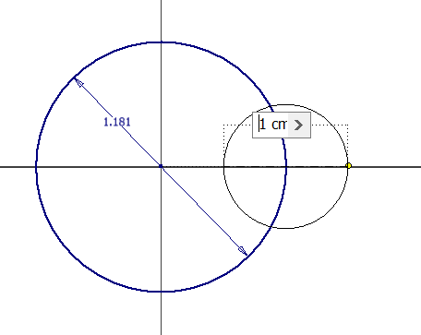

Outer Diameter Circle – center same as the center of the first circle drawn, 5.2 cm

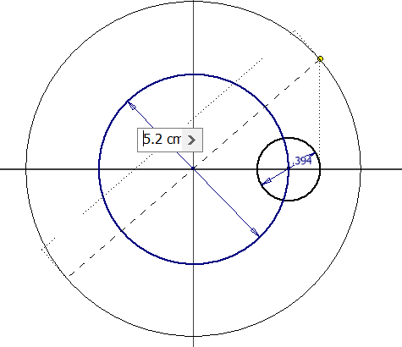

Draw a line across the center of the smallest circle straight down

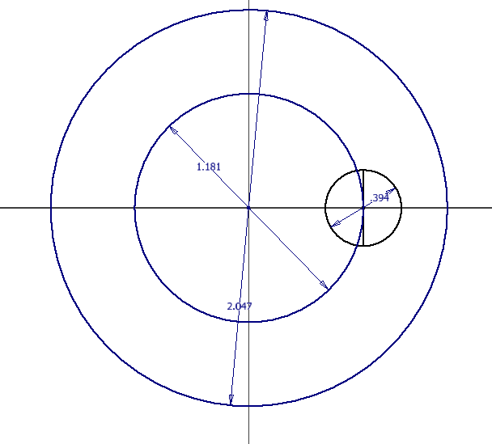

Draw a line in from the edge of the circle. Here I picked 0.45 cm arbitrarily

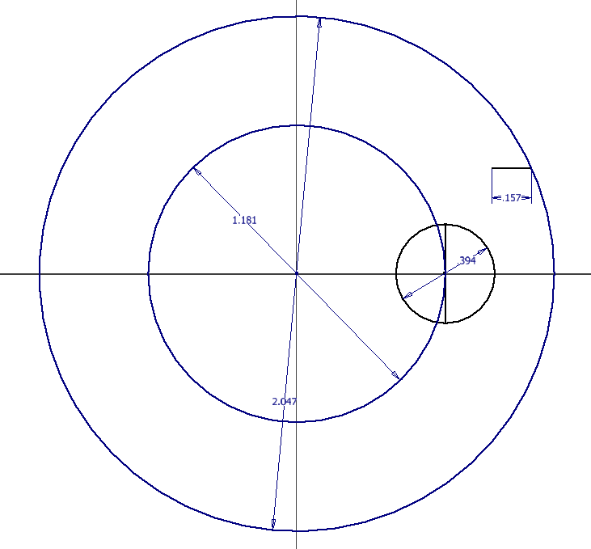

Connect the line inside of the smallest circle to the line just drawn with arcs – angle and parameters not yet defined

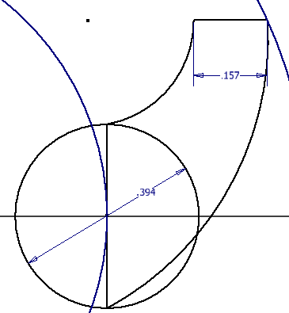

Delete the circles, leaving a profile of some kind

